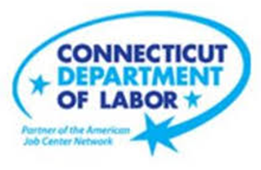

**NEW WEEKLY JOB POSTINGS FROM   
HELP WANTED ONLINE  
Office of Research**

**Week Ending April 8th, 2023: Weekly New Ads Jump 33% From A Week Ago**WETHERSFIELD, April 14th, 2023 – During the week ending April 8th, 2023, there were 9,662 new postings, up 2,395 new ads or 33% over the week. This over-the-week jump positions the most recent week of total new ads as the second-highest level in over a year. The 12-month high of 9,921 weekly new ads occurred during the week ending June 11th, 2022. The five largest industry increases over the week were up between 140 and 572 new ads and grew between 24%-90%. The largest industry increase was Retail Trade, up 572 new ads or +90% over a week ago. The Home Depot was the largest Retail Trade employer increase, up 162 new ads over the week. Other employers with large increases include Yale-New Haven Healthcare (+211 new ads), UnitedHealth Group (+163 new ads), and Hartford Healthcare (+162 new ads). The pronounced increases over the past few weeks are shown in the graph below and occurred at both the statewide and U.S. levels. Systems issues have affected the quality of the data over the past few weeks.  
  
  
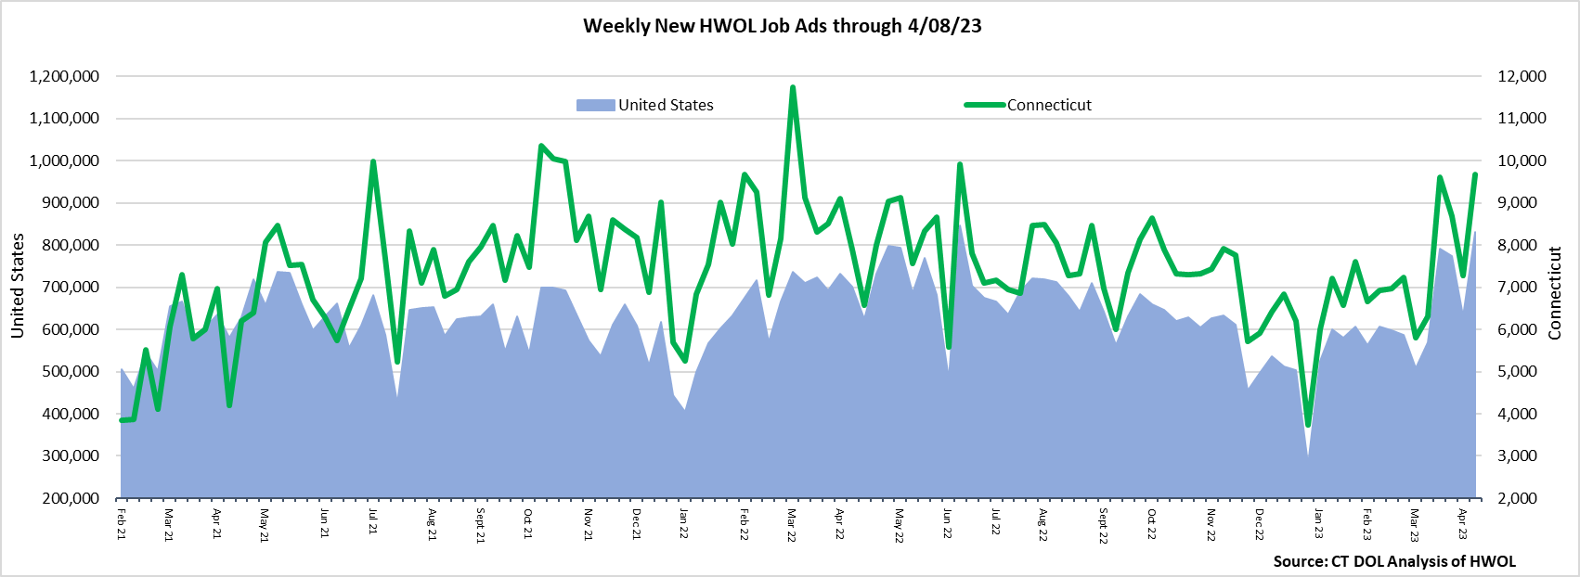  
**Industries** with the most new postings include Health Care & Social Assistance, Retail Trade, and Finance & Insurance.

**Occupations** with the most new postings include Registered Nurses, Retail Salespersons, and First-Line Supervisors of Retail Sales Workers.

**Employers** with the most new postings include Yale-New Haven Health System, Hartford Healthcare, and UnitedHealth Group.

**The three industries with the most new job postings were:**

* **Health Care & Social Assistance** (2,249 new postings, +24% over the week)
* **Retail Trade** (1,211 new postings, +90% over the week)
* **Finance & Insurance** (900 new postings, +73% over the week)

   
 During the week ending April 8th, 2023, nineteen of twenty-one industries had over-the-week increases. More than half of the 2,395 new ad total increase occurred in one of three industries; Retail Trade (+572 new ads), Health Care & Social Assitance (+436 new ads), and Finance & Insurance (+379 new ads). These three industries represented a combined 58% of over-the-week change and 45% of new ads during the current week. The employers with the most ads within those three industries respectively were The Home Depot (154 new ads), Yale-New Haven Health System (361 new ads), and UnitedHealth Group (192 new ads). Total new ads are up 3,359 from four weeks ago. All but two industries had four-week increases. The three largest were Health Care & Social Assitance (+790 new ads), Retail Trade (+671), and Finance & Insurance (+437 new ads).   
  
 For more information on total job ads by industry for Connecticut and its labor market areas, see the monthly report available here: <https://www1.ctdol.state.ct.us/lmi/hwol.asp>

**New Job Postings by Occupation** 

**The occupations with the most new postings were:**

* Registered Nurses (560 new postings, +11% over the week)
* Retail Salespersons (352 new postings, +45% over the week)
* Supervisors of Retail Sales Workers (279 new postings, +91% over the week)

**Employers with the Most New Job Postings** Employers with the most new job postings during the week ending April 8th, were mostly within Health Care & Social Assistance, Retail Trade, and Finance & Insurance. Health Care & Social Assistance accounted for eight of the top 25 employers and seven were in Retail Trade. The 25 employers shown above combined account for 2,151 of total job ads or 22 percent of all new ads. The four employers with the most new ads during the week had between 152 and 211 more new ads than a week ago. Twenty-three of twenty-five employers had over-the-week increases, the two down over-the-week were Keystone Human Services (-31 new ads) and Masonicare Corp. (-26 new ads)  
  
**What is HWOL?**The **Conference Board Help Wanted Online**® Data Series (HWOL) measures the number of new, first-time Online job postings and jobs reposted from the previous month for over 16,000 Internet job boards, corporate boards, and smaller job sites that serve niche markets and smaller geographic areas. To view more HWOL data, go to: <https://www1.ctdol.state.ct.us/lmi/hwol.asp>